I’M A PARENT GET ME OUT OF HERE!
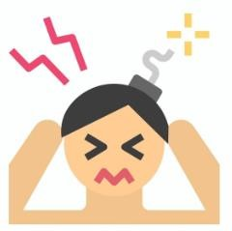

6-week positive parenting programme. I’m a Parent is an opportunity for parents to come together as part of a course, share their experiences and discover new perspectives and strategies.
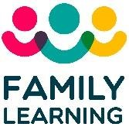


Sessions Include:
Bex

–

repert@aberdeencity.gov.uk

Sophie
-

seyre@aberdeencity.gov.uk

- Parenting experience
- Parenting skills & strategies
- Exploring Influencing factors on parenting
- Techniques to relax & destress.

To register your interest, scan & complete the form via the QR code or link:
https://forms.office.com/e/hyKF2gqzcb
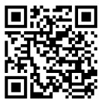
Venue: Online Via MS Teams
Date: Part 1: 6th, 13th & 20th March - 1:45-2:30pm Part 2: 17th, 24th April & 1st May – 1:45-2:30pm
For more information contact:

