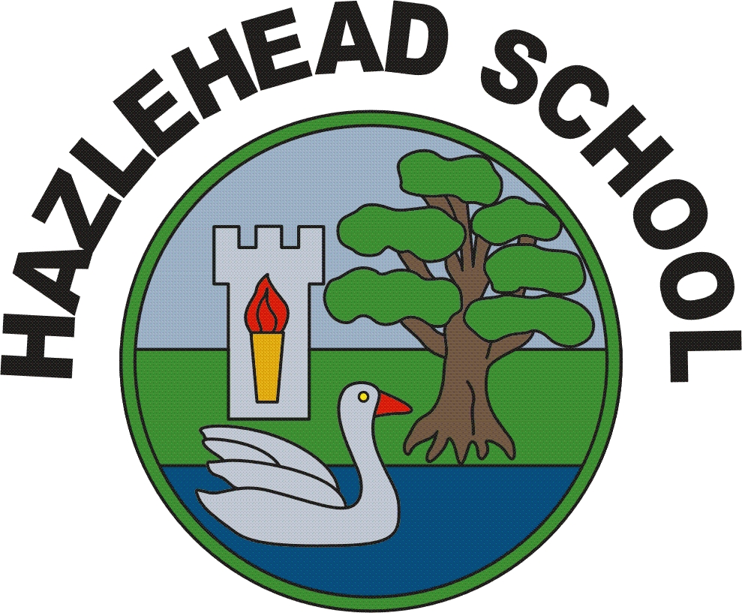
HAZLEHEAD SCHOOL
PROVOST GRAHAM AVENUE
ABERDEEN
AB15 8HB
TELEPHONE: 01224 498120 eMail:hazleheadprimary@aberdeencity.gov.uk
SCHOOL WEBSITE: www.hazlehead-ps.aberdeen.sch.uk/
HEAD TEACHER: MRS. JONES

“When you believe in yourself, anything is possible.”




Friday 5th October 2022
“Autumn is a second spring when every leaf is a flower.”


SCHOOL NEWSLETTER

SCHOOL IMPROVEMENT
A new school year means new school targets, so we have been very busy identifying our priorities for this session. Included in these priorities is looking at different ways which we can strengthen parental partnerships so that you feel very much part of the life at Hazlehead. We have created a plan which sets out clear, achievable targets and have made both parent and child friendly versions so that the school community is aware of what we are trying to achieve. This can be found here. School Improvement Plan

JEWELLERY
Please can I ask that pupils do not wear jewellery to school apart from small stud earrings. On the days that your child has P.E, stud earrings should be removed or taped for health and safety reasons.

HEALTH AND WELLBEING
Our Health Group will soon be sending out a Google Form to find out about the different types of activities pupils do outside school. Please complete this as it helps to give us a fuller picture of our learners as individuals.

CROMDALE
Several weeks ago, the P7 pupils visited Cromdale for their residential trip. They have made a video of their adventures which can be found here. https://www.wevideo.com/view/2817245517
UNFORM
Please be reminded that pupils should only wear their P.E clothes on the days that they have P.E. You can find this information on your child’s termly overview on the school website. For the remainder of the school week, pupils should wear their school uniform.

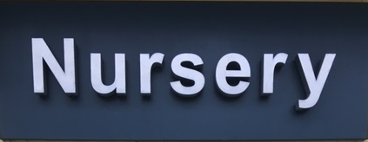
WHAT’S BEEN HAPPENING IN ELC?
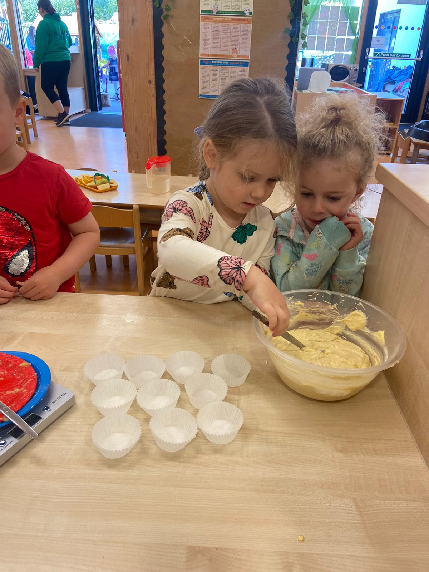
WE’VE BEEN BAKING BANANA CAKES!
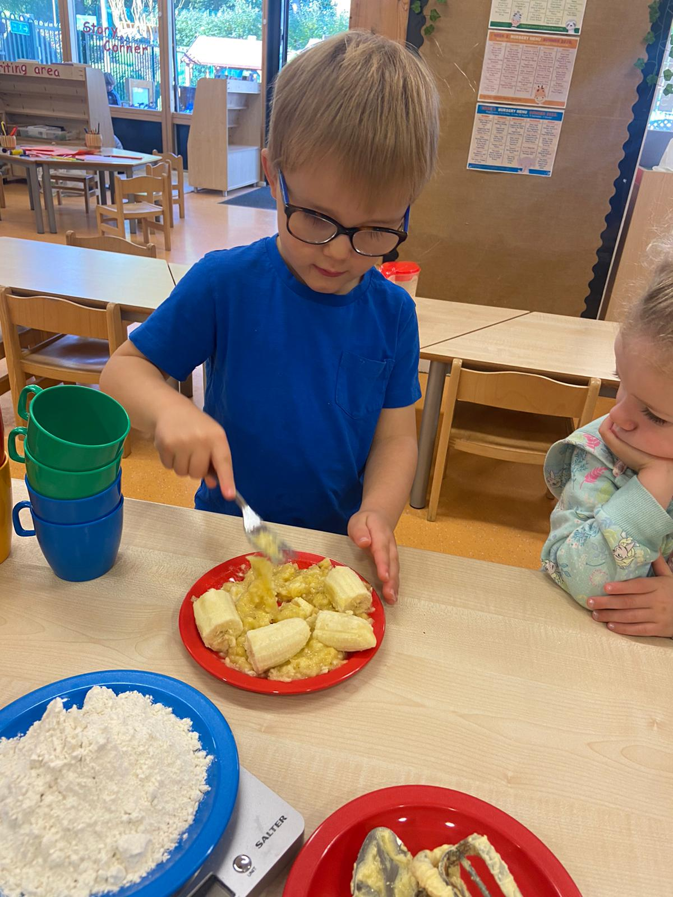
This week, the children decided to bake banana cakes.
It was a great opportunity to discuss daily hygiene such as
washing our hands before cooking. We discussed healthy and
unhealthy foods and the boys and girls did very well taking
turns. Great teamwork!

This week’s Incredible Work focuses on creativity and can be found here
Kind regards,
Barbara Jones 😊

